Saranagati
Fencing
Project

SVHI owns nearly 2000 acres of land. We are the only non rancher, non commercial entity in the entire region (perhaps in all of western Canada) holding that volume of land resource. What we choose to do with the land tells the world who we are. Our entrance sign announces that this community project is dedicated to A.C. Bhaktivedanta Swami Prabhupada, therefore the choices we make for managing our land is also a reflection on Srila Prabhupada.

In 2006 it was documented by an independent 3rd party study funded by the government that the overgrazing by beef cattle in Venables Valley had a number of negative and environmentally destructive consequences. Specifically the overgrazing was resulting in a loss of flora species, introduction of invasive weeds, and increased volumes of pest
populations. If left unchecked, the study concluded, such a practice would eventually turn former hay fields into lifeless hard-pan. That same study also noted that the entire riparian zone of Venables Valley was being degraded by trampeling. Unfortunately the laws of the land favor the ranchers. If we wanted to prevent unrestricted beef cattle on our land it was going to be our responsibility to fence them out, that's the
law, that's what all private land owners do.

At the 2014 AGM we SVHI shareholders formally accepted the challenge to take back Krishna's land. We terminated the contract with Bob Pasco, applied for our own farm status, and began the process of fencing our land.

The attached map explains in a glance how much fencing has been completed since then and how much fencing remains to be finished. The lay of our land is such that we do not have to fence every single foot of our property boundaries. In many places steep hillsides act as natural barriers which prevent access by cattle. Along with the map is a breakdown of costs thus far and a projection of costs for finishing the project and for maintaining the fence once it is completed.

The Vaisnava's vision is that the earth is a divine being, a goddess. Taking this opportunity to use our land as a vehicle for Krishna's service is indeed “Bhakti Yoga, Country Style” and is a living confirmation of our belief that the earth truly is sacred. Having a share in 2000 acres of land is a responsibility. It also affords us a chance to demonstrate our inspiration to please and serve God.
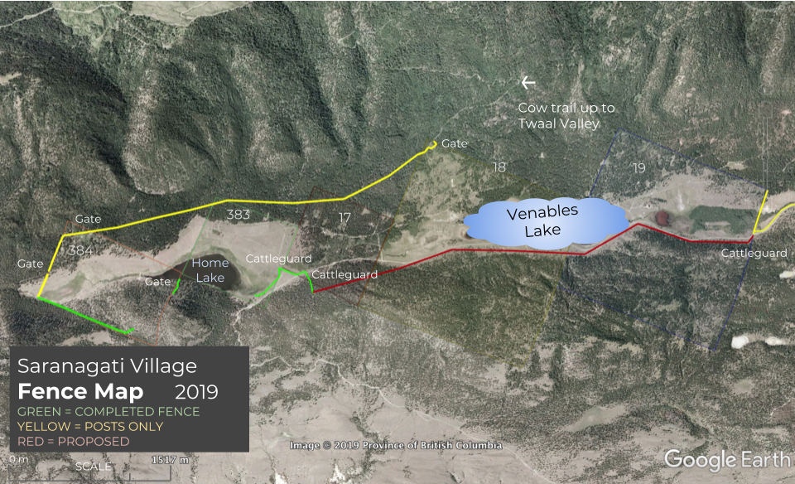
Two Views of a Proposed East Side Fence

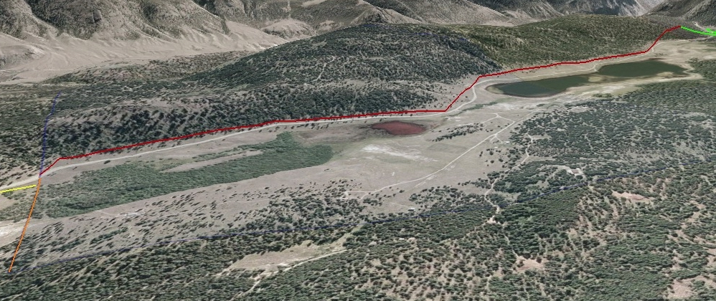

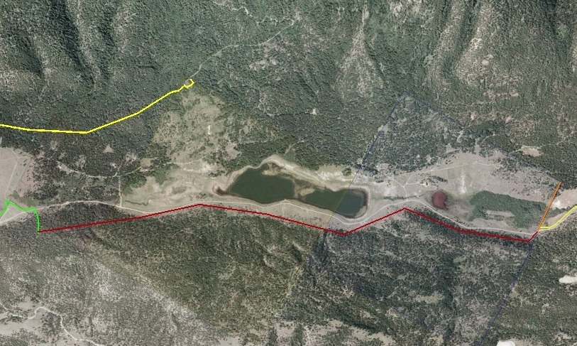

North End Cattleguard
and Fences
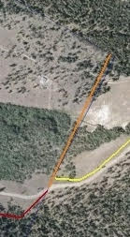

Professional Input

Most Prominent Fencer in our Area:

2 hrs/km per year to maintain a fence
A good fence will last 30 years in good working order
In order to get this lifespan out of a fence we must use certified posts

Kamloops Fencing Company:

$20,000/km, cost of fencing

Cattleman’s Association:

Fence doesn’t need to be replaced. Simply needs to be maintained. Cost of maintenance when it needs to be done is a $1/metre.

Budget

We would like to note that these figures are a high estimate and that costs could potentially be lower.

$4700 currently left in the budget for fencing

$56,000 has been spent to date
$12,000 to finish the south end
$38,000 - $45,000 to complete the north end
$50/year/share to maintain (This maintains and completely replaces the fence every 30 years)

Breakdown of Budget to Finish South End

Posts - $1400 for 100 including delivery
- posts will be used for bracing and to replace those that have broken

Cost of Machine - $4000 (could be less, depends on how much work is
to repound and involved}
Straighten

Wire - $4000 for 4km

Staples?

Labour?

Other Expenses

Gate - $250 for a gate on Minnabariet road. This is a new part of the south end boundary fence running from Bhakti Raghava Swamis’s cabin to the existing perimeter fence. The posts are pounded. All other costs are included in the estimate.

Management Procedure

- The Fence Project manager will make a detailed proposal to the board of directors for the section of fence to be worked on. The proposal will include an estimate from the contractor for materials and labour as well as a timeline. .

- The Board of Directors either releases the money or asks for more revisions until satisified to release the money.

- The community will be updated through monthly board meeting minutes of the ongoing workings of the project.

- All receipts are submitted to the treasurer.

- When project is completed, community is informed with completed budget and timeline.

